Charles County Public Schools

Student Service Learning
Individual Activity Packet

Home and Hospital Program

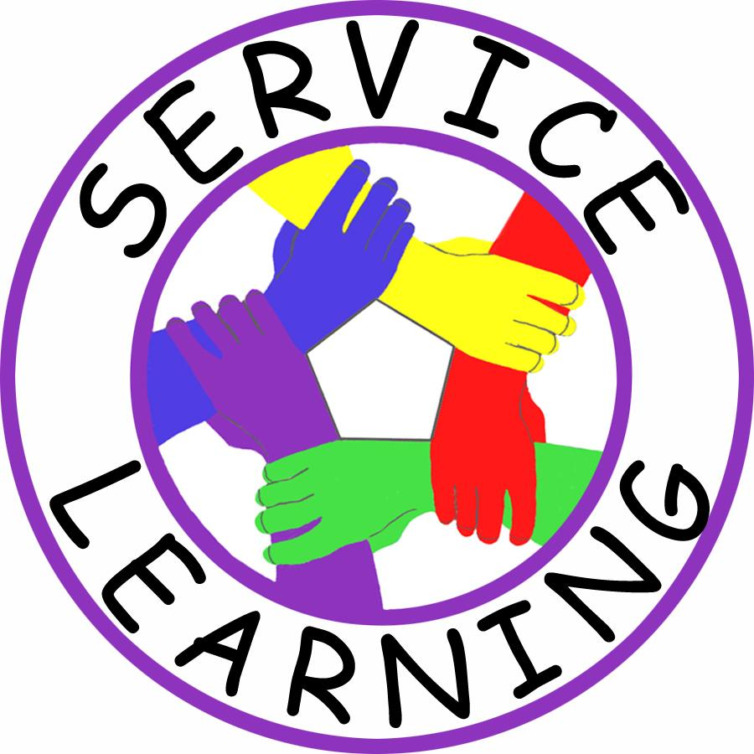

Student Name _________________________________________________

Teacher Name _________________________________________________

Date Started __________________ Date Completed _________________

Charles County Public Schools
Revised June 2016
STUDENT SERVICE LEARNING

Charles County Public Schools infuses all elements of service learning throughout several disciplines and over several grades at the middle and high school levels. In an effort to enhance the quality of student’s service learning experience in Charles County Public Schools, the program offers students the opportunity to recover service-learning credit necessary for graduation through a Service-Learning Individual Activity Packet.

This document of secondary interdisciplinary service learning tasks (including Preparation, Action, and Reflection), is offered as a guide to independent projects for those students who need to complete their service-learning requirement in order to receive a Maryland state diploma and graduate from Charles County Public Schools.

INSTRUCTIONS

Home and Hospital students needing to complete their service learning in order to graduate must complete this packet including all preparation, action, and reflection tasks. All service-learning completed for this Individual Activity Packet is to be done on ONE (1) topic or issue, NOT on multiple issues.

This packet provides Home and Hospital students with the instructions and resources to complete an Advocacy project for their service learning. Advocacy projects involve activities and opportunities for students to lend their voices and talents to address a particular community issue.

A well-planned reflection and Student Service Learning Project should include the following:
7 Best Practices for Student Service Learning:
1. Meet a recognized need in the community 4. Develop student responsibility
2. Achieve curricular objectives 5. Establish community partnerships
3. Reflect throughout service-learning experience 6. Plan ahead for service-learning
7. Equip students with knowledge and skills needed for service

All original independent projects must be approved prior to beginning. Please consult your service learning coordinator for any questions or comments.

For Home and Hospital Instructors with questions about the Service-Learning process, the contact information for the county SSL Coordinator is provided below:

Jack W. Tuttle (Social Studies Content Specialist and Service-Learning Coordinator)
Jesse L. Starkey Administration Building
Department of Instruction
(301) 934-7405
jtuttle@ccboe.com

Service – Learning Project Log

DIRECTIONS: You must keep a log of all activities you complete as part of your project. This includes all parts of the Preparation, Action and Reflection components of your project. Record that information in the chart below. Label whether each Activity is part of your Preparation (P), Action (A), or Reflection.

Date | Type  (P, A, R) | Activity Completed | Home & Hospital Teacher  Initials

DIRECTIONS: This part of the project requires a student to conduct interviews of persons in their community. The purpose is to inform students about what issues are of concern to residents of southern Maryland. Information gathered from these interviews may be used by students to decide on the topic of their service-learning project. The interviews can be completed in person, by phone, or by email correspondence.

Community Interview #1

Name of Person ________________________________________________________

Occupation: ________________________________ Age: _______ (minimum of 21)

- How long have you been a resident of Maryland? ____________________

- What services in southern Maryland do you use the most?

__________________________________________________________________________________________________________________________________________________________________________________________________________________

- Which goods and services would you like to see in southern Maryland that are not currently available?

__________________________________________________________________________________________________________________________________________________________________________________________________________________

- What leisure and recreational activities do you enjoy in southern Maryland?

__________________________________________________________________________________________________________________________________________________________________________________________________________________

- List two or three advantages to living in southern Maryland.

__________________________________________________________________________________________________________________________________________________________________________________________________________________

- What challenges do you believe southern Maryland faces?

__________________________________________________________________________________________________________________________________________________________________________________________________________________ ______________________________________________________________________

- If you could change anything in southern Maryland, what would it be? Why?

________________________________________________________________________________________________________________________________________________________________________________________________________________________________________________________________________________________

- Additional Comments:

__________________________________________________________________________________________________________________________________________________________________________________________________________________

- This interview helps me identify a topic for service-learning? Why or Why not?

________________________________________________________________________________________________________________________________________________________________________________________________________________________________________________________________________________________
DIRECTIONS: This part of the project requires a student to conduct interviews of persons in their community. The purpose is to inform students about what issues are of concern to residents of southern Maryland. Information gathered from these interviews may be used by students to decide on the topic of their service-learning project. The interviews can be completed in person, by phone, or by email correspondence.

Community Interview #2

Name of Person ________________________________________________________

Occupation: ________________________________ Age: _______ (minimum of 21)

- How long have you been a resident of Maryland? ____________________

- What services in southern Maryland do you use the most?

__________________________________________________________________________________________________________________________________________________________________________________________________________________

- Which goods and services would you like to see in southern Maryland that are not currently available?

__________________________________________________________________________________________________________________________________________________________________________________________________________________

- What leisure and recreational activities do you enjoy in southern Maryland?

__________________________________________________________________________________________________________________________________________________________________________________________________________________

- List two or three advantages to living in southern Maryland.

__________________________________________________________________________________________________________________________________________________________________________________________________________________

- What challenges do you believe southern Maryland faces?

__________________________________________________________________________________________________________________________________________________________________________________________________________________ ______________________________________________________________________

- If you could change anything in southern Maryland, what would it be? Why?

________________________________________________________________________________________________________________________________________________________________________________________________________________________________________________________________________________________

- Additional Comments:

__________________________________________________________________________________________________________________________________________________________________________________________________________________

- This interview helps me identify a topic for service-learning? Why or Why not?

________________________________________________________________________________________________________________________________________________________________________________________________________________________________________________________________________________________

Community Issue Research

DIRECTIONS: In this part of the project, students identify how community issues are addressed in the region. The purpose is to inform students about what issues exist, who is addressing them, and how they are currently being addressed. Information gathered from this research is used by students to decide on the topic of their service-learning advocacy project.

List of Approved Issues (Check 2 of these issues):

- _______Environmental Issues
- _______Hunger, Homelessness, and Poverty
- _______Literacy (Educational Needs)
- _______Public Safety
- _______Substance Abuse

DIRECTIONS: Research the information below on the two topics you selected above.

Issue #1: ______________________________________________________________

Identify one agency addressing Issue #1: ____________________________________

Describe what this agency does to address Issue #1: ________________________________________________________________________________________________________________________________________________________________________________________________________________________________________________________________________________________

Issue #2: ______________________________________________________________

Identify one agency addressing Issue #2: ____________________________________

Describe what this agency does to address Issue #1: ________________________________________________________________________________________________________________________________________________________________________________________________________________________________________________________________________________________

Service- Learning Issue

DIRECTIONS: This part of the project requires a student to identify the topic for their service-learning project. The purpose is for students to have a specific issue for their project that meets the requirements for service-learning.

SSL Project Issue: ______________________________________________________

Agency Contact (Supervisor): _____________________________________________

Write a brief explanation of the issue you will address in your Student Service Learning Project.

______________________________________________________________________________________________________________________________________________________________________________________________________________________________________________________________________________________________________________________________________________________________

Write a brief statement explaining why the Student Service Learning Project you have selected is an important community issue.

______________________________________________________________________________________________________________________________________________________________________________________________________________________________________________________________________________________________________________________________________________________________

YOU MUST HAVE BOTH SIGNATURES BEFORE YOU CAN BEGIN WORK ON THIS SERVICE LEARNING PROJECT.

___________________________________________ ___________________
Parent or Guardian Signature Date

__________________________________________________ ______________________
Home & Hospital Teacher Signature Date

Community Issue in the News #1

DIRECTIONS: This part of the project requires a student to research their issue in the news. The purpose is to inform students about their chosen issue. Information gathered from this research should be used by students to finalize the preparation portion of their service-learning project.

Use a newspaper, magazine, or news website article on your issue. Read the source and answer the questions below. One of the best sources for this information is the ProQuest SIRS® Issues Researcher located on the Charles County Public Schools Library Media website. When accessing the from home, the Username is charlescounty and the password is welcome.

News Source _______________________________ Date of News Source _________

Title of Article _________________________________________________________

Author________________________________________________________________

Summarize the article. In your summary, include the following information:

What issue is being addressed? ___________________________________________

Why is this issue important? ______________________________________________
__________________________________________________________________________________________________________________________________________________________________________________________________________________

How does this issue impact the community? _________________________________
__________________________________________________________________________________________________________________________________________________________________________________________________________________

What is being done to address this issue? ___________________________________
________________________________________________________________________________________________________________________________________________________________________________________________________________________________________________________________________________________
Community Issue in the News #2

DIRECTIONS: This part of the project requires a student to research their issue in the news. The purpose is to inform students about their chosen issue. Information gathered from this research should be used by students to finalize the preparation portion of their service-learning project.

Use a newspaper, magazine, or news website article on your issue. Read the source and answer the questions below.

News Source _______________________________ Date of News Source _________

Title of Article _________________________________________________________

Author________________________________________________________________

Summarize the article. In your summary, include the following information:

What issue is being addressed? ___________________________________________

Why is this issue important? ______________________________________________
__________________________________________________________________________________________________________________________________________________________________________________________________________________

How does this issue impact the community? _________________________________
__________________________________________________________________________________________________________________________________________________________________________________________________________________

What is being done to address this issue? ___________________________________
________________________________________________________________________________________________________________________________________________________________________________________________________________________________________________________________________________________

Service Agency Form

DIRECTIONS: This part of the project requires a student to identify and answer questions about an agency or organization that works on the issue you have chosen for your project. Complete the information below on this agency or organization. Please see page 13 of this packet for a list of agencies.

Date: ___________________________________________

- Identify the agency: _______________________________________________

- Agency Contact Information: ________________________________________
____________________________________________________________________________________________________________________________________________

- What is the purpose of this agency?

________________________________________________________________________________________________________________________________________________________________________________________________________________________________________________________________________________________

- What impact does this agency’s actions have on the community (related to
your issue)?
______________________________________________________________________________________________________________________________________________________________________________________________________________________________________________________________________________________________________________________________________________________________________________________________________________________________________________________________________________________________________________________________________________________________________________________________________________________________________________________

Service Learning Action

DIRECTIONS: Students now complete the Action component of their service learning project. Students must check below the issue they have already chosen, and then identify 2 ways they will use to advocate for addressing this issue. Please see page 13 of this packet for a description of these choices.

*Writing 2 letters is a mandatory component. Students must also complete one of the other two options.

(√) | ISSUE | (√) | ACTION CHOICES (Choose 2)
 | Environmental Issues |  | Create a poster collage with pictures showing the environmental issues in your local area.
 |  |  | Create a brochure supporting environmental protection based on local issues.
 |  |  | *Write and mail letters to 2 local officials in favor of current environmental legislation.
 | Hunger, Homelessness, and Poverty |  | Create a poster collage depicting contrasts between poverty and wealth.
 |  |  | Create a brochure showing agencies and methods to address local hunger issues.
 |  |  | *Write and mail letters to 2 local officials supporting assistance for the homeless.
 | Literacy (Educational Needs) |  | Create a poster collage demonstrating the importance of reading and writing skills.
 |  |  | Create a brochure advocating for more technology resources for students in need.
 |  |  | *Write and mail letters to 2 local officials advocating for increased school funding.
 | Public Safety |  | Create a poster collage showing the ways in which children can promote safety at home.
 |  |  | Create a brochure demonstrating the signs of bullying and how to prevent it.
 |  |  | *Write and mail letters to 2 local officials on maintaining youth recreation programs.
 | Substance Abuse |  | Create a poster collage on the dangers and effects of drug abuse.
 |  |  | Create a brochure for parents on how to teach their children about drug abuse prevention.
 |  |  | *Write and mail letters to 2 local officials in support of more funding for drug prevention.

Service Learning Action – Component Guidelines

DIRECTIONS: Students must now complete the Action component of the project. The guidelines for these components are listed on the next two pages.

- Letter to 2 Public Officials (required)

This part of the project must:
- be typed on an 8 ½ x 11 sheet of paper using the format on the next page
- address the topic identified for the chosen issue
- be signed by the student and mailed to the chosen public official addresses (see below)
- include an extra copy of each letter to submit with this packet

Addresses for local public officials can be found on the following websites:

Government Organization | Address Option #1 | Address Option #2
Charles County Board of Commissioners | Charles County Board of Commissioners  P.O. Box 2150, La Plata, MD 20646 | Charles County Commissioners Contact Information
Charles County Community Services | Charles County Community Services  8190 Port Tobacco Rd., Port Tobacco, MD 20677 | Community Services Contact Information
Maryland Government Officials | Maryland Delegate Contact Information | Maryland Senator Contact Information

- Poster Collage OR Brochure

Choose one of the following options below. Along with the two letters written to public officials, this will be the Action component of the project.

OPTION #1 - Poster Collage Guidelines

This part of the project must:
- be completed on at least 22” x 28” poster board
- include pictures/photos as well as written information
- address the topic identified for the chosen issue

OPTION #2 - Brochure Guidelines

This part of the project must:
- be completed on 8 ½ x 11 paper or card stock and folded into a tri-fold brochure
- include pictures/photos as well as written information
- address the topic identified for the chosen issue

Letter to Public Official - Template

DIRECTIONS: Below is an sample of how a letter to a public official should be completed. Students should use this example to help them complete the 2 letters on their own topic.

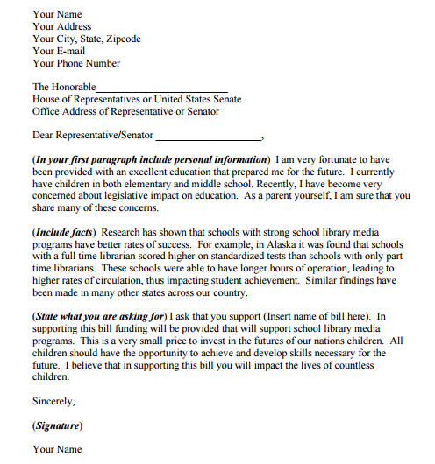

Student Name: _____________________________________ School: _________________________ Grade: _____

Student ID#: _______________ Type of Service (Circle One): DIRECT INDIRECT ADVOCACY

Charles County Public Schools
Service-Learning Program
Reflection Essay

A well-planned Student Service Learning Project should include all components of the 7 Best Practices (see the list on the reverse side of this form). The third and final phase of a service-learning project is a reflection about the experience. This reflection requires as much effort as the preparation and action phases of service-learning. Your reflection should be well thought out. It should consist of 6 paragraphs using the format below.

Unless checked below, this reflection sheet also indicates this student has completed the Preparation and Action portions of the SSL project also.

 | Preparation Incomplete |  | Action Incomplete |  | Both Portions Incomplete

- Paragraph 1 – Describe how your project meets a recognized need in the community.

__________________________________________________________________________________________________________________________________________________________________________________________________________________________________________________________________________________________________________________________________________________________________________________________________________________________________________________________________________________________________________________________________________________________________________________________________________________

- Paragraph 2 – Describe how you gained skills and knowledge through this project.

__________________________________________________________________________________________________________________________________________________________________________________________________________________________________________________________________________________________________________________________________________________________________________________________________________________________________________________________________________________________________________________________________________________________________________________________________________________

- Paragraph 3 – Describe how you planned in advance to organize your project.

__________________________________________________________________________________________________________________________________________________________________________________________________________________________________________________________________________________________________________________________________________________________________________________________________________________________________________________________________________________________________________________________________________________________________________________________________________________
- Paragraph 4 – Describe how you worked on this project with a service organization(s).

__________________________________________________________________________________________________________________________________________________________________________________________________________________________________________________________________________________________________________________________________________________________________________________________________________________________________________________________________________________________________________________________________________________________________________________________________________________

- Paragraph 5 – Describe how you developed responsibility by completing this project.

__________________________________________________________________________________________________________________________________________________________________________________________________________________________________________________________________________________________________________________________________________________________________________________________________________________________________________________________________________________________________________________________________________________________________________________________________________________

- Paragraph 6 – Describe how this project by completing this project.

__________________________________________________________________________________________________________________________________________________________________________________________________________________________________________________________________________________________________________________________________________________________________________________________________________________________________________________________________________________________________________________________________________________________________________________________________________________

Student Service-Learning
7 (Seven) Best Practices

- The student meets a recognized need in the community.
- The student achieves curricular objectives. (not necessary for the student reflection)
- The student gains necessary knowledge and skills.
- The student plans ahead.
- The student works with existing service organizations.
- The student develops responsibility.
- The student reflects throughout the experience.

Rubric for SSL Reflection Essay

Scoring Guidelines

Teacher’s using the 4-point rubric should first consider the ideas and understanding the student displays in the reflection. It is important for the student to have incorporated all of the required components and have a minimum of six paragraphs.

Teachers who wish to assign a numerical value to the essay may consider scores of 4 worth 20 points; 3 worth 15 points, 2 worth 10 points, and 1 worth 5 points. In this way, a total of 100 points is achieved with a perfect score in all categories.

CATEGORY | LEVEL 4  STRONG | LEVEL 3  EFFECTIVE | LEVEL 2  DEVELOPING | LEVEL 1  NEEDS  IMPROVEMENT
The student meets a recognized community need | Need and its relevance are clearly identified through research or a need assessment | Need and its relevance are clearly identified and focused upon throughout the project | Need identified but its relevance to community is not explored in depth | Minimal or no need identified
The student gains necessary knowledge and skills | Reflection completed throughout the project addressing various learning styles and exploring causes of need, project impact, and personal and academic growth | Reflection completed periodically throughout the project addressing root causes of issues | Brief reflection evident at conclusion of project | Minimal or no reflection evident
The student plans for the experience | Students responsible for project creation, organization, and implementation | Students share responsibility with teacher for project development and implementation | Students given some choice in project development | Minimal or no student responsibility evident
The student works with existing service organizations | Students and community partner(s) collaborate as an action team on project | Students interact/meet with community partner(s) | Limited contact with community partner(s) for information and resources | Minimal or no community partnerships made
The student develops responsibility | Extensive planning evident to focus the student service-learning project on meeting the need and goals | Adequate planning evident to meet the community need and curricular goals | Some planning evident | Minimal or no planning evident
The student reflects throughout the experience | Student equipped with demonstrable knowledge/skills about the community need, causes, and about active civic engagement | Knowledge/skill obtained about the community need, causes, and about civic engagement | Some knowledge/skills obtained about the community need and its cause | Minimal or no attempt made to obtain knowledge and skills

